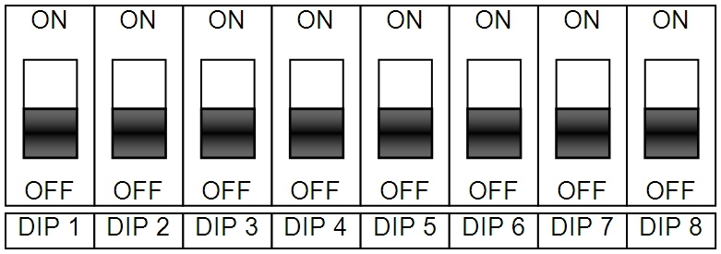
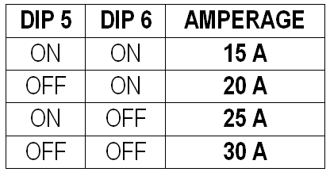
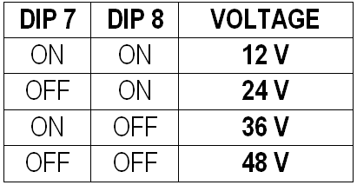
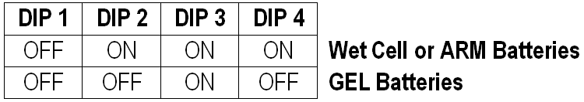
Wet Cell or AGM Batteries
Gel Batteries

Dip Switch LOCATION
The battery charger that was provided with the equipment is an advanced programmable battery charger that can be optimized to provide the best type of charging for your specific battery pack. To access the programming DIP Switches your must remove the hard plastic label on the front of the charger. Be certain that the battery charger is unplugged from supply AC voltage and be certain that the battery charger is disconnected from the battery pack.

Battery Charger PROGRAMMING
Determine what the nominal DC operating voltage of the machine, the type of batteries in the machine and the Amp Hour rating of the batteries. Please note that charging amperage that you program into the battery charger should equate to roughly 10% of the Amp Hour rating of the batteries. Follow the diagrams below to optimize the charging profile for the battery pack installed in the machine.
BATTERY TYPE

NOMINAL BATTERY PACK
VOLTAGE
CHARGER AMPERAGE
OUTPUT
(10% of Battery AH Rating)

Technical Bulletin 20090326-2

S.P.E. BATTERY CHARGER SETTINGS

